1. Write the program to find the family relation and sum of two numbers.

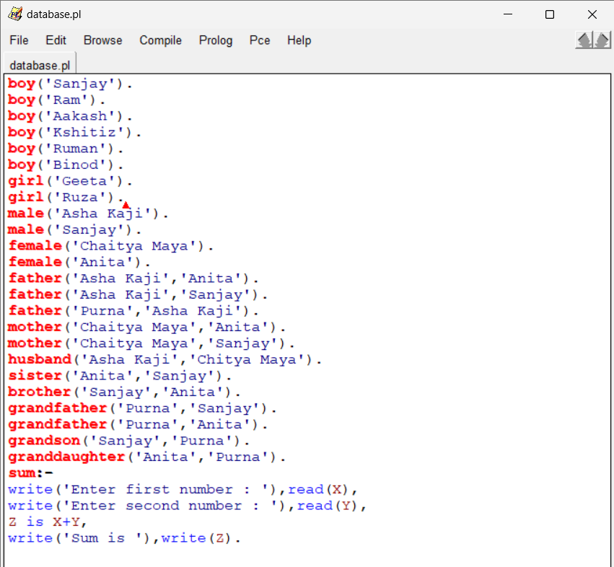

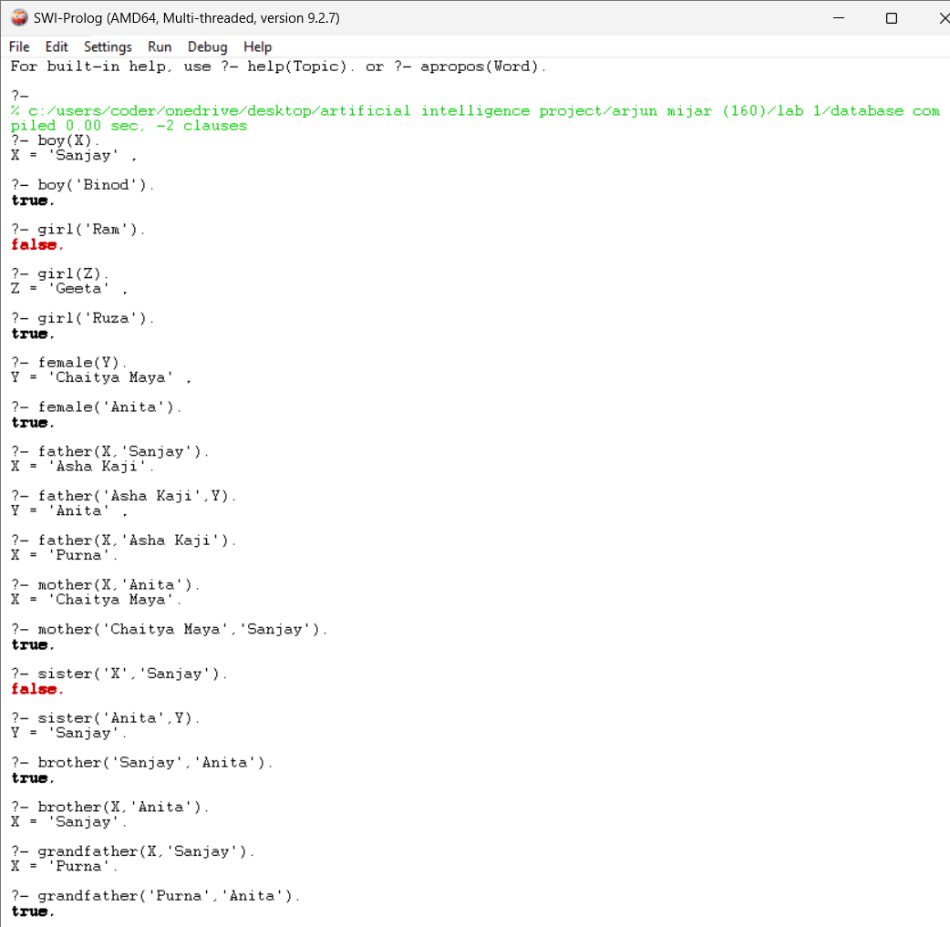

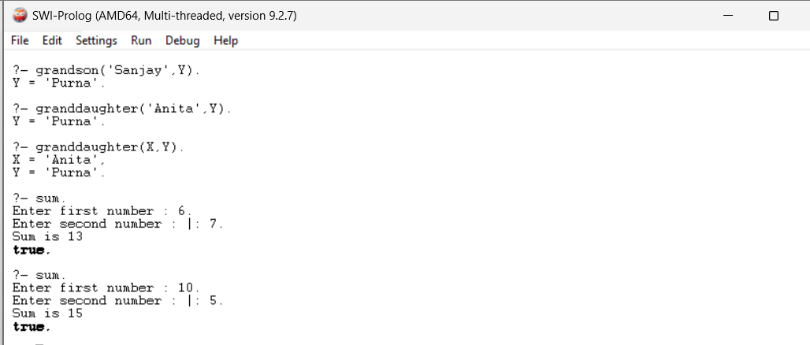

2a. Write a program to find the area and perimeter of a rectangle.

Write a program to find the area and circumference of a circle.

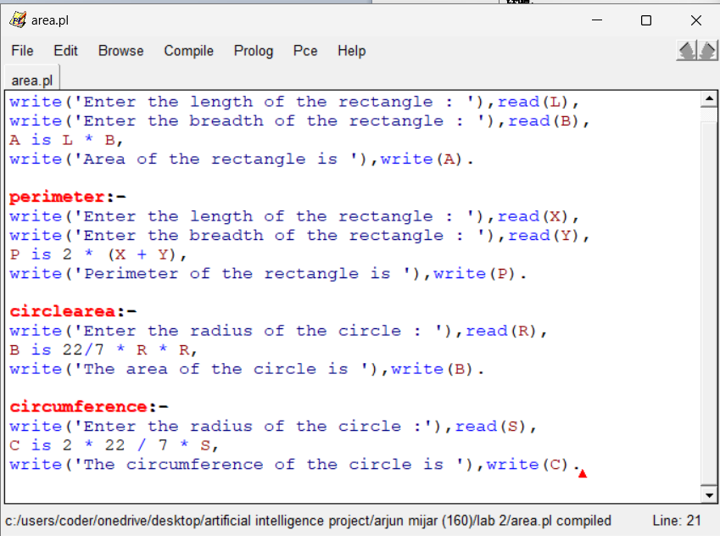

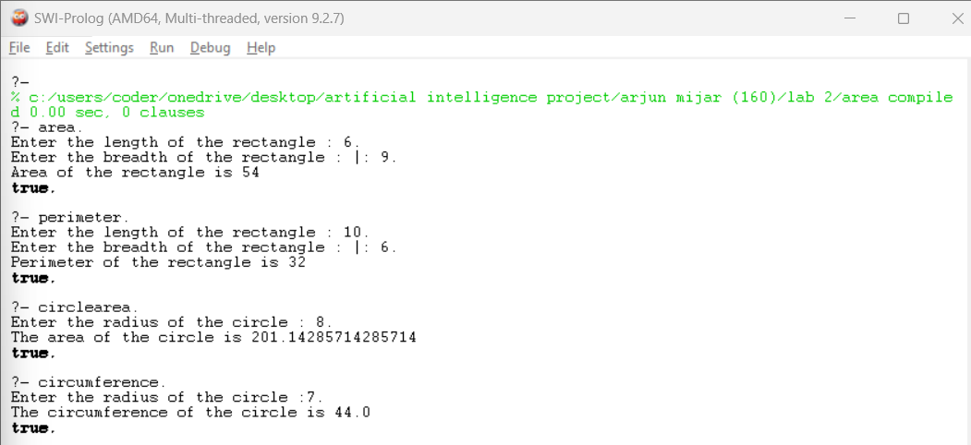

2b. Write a program to find the sum, difference, multiplication, division, and integer division.

Write a program to find the square, cube, and modulus.

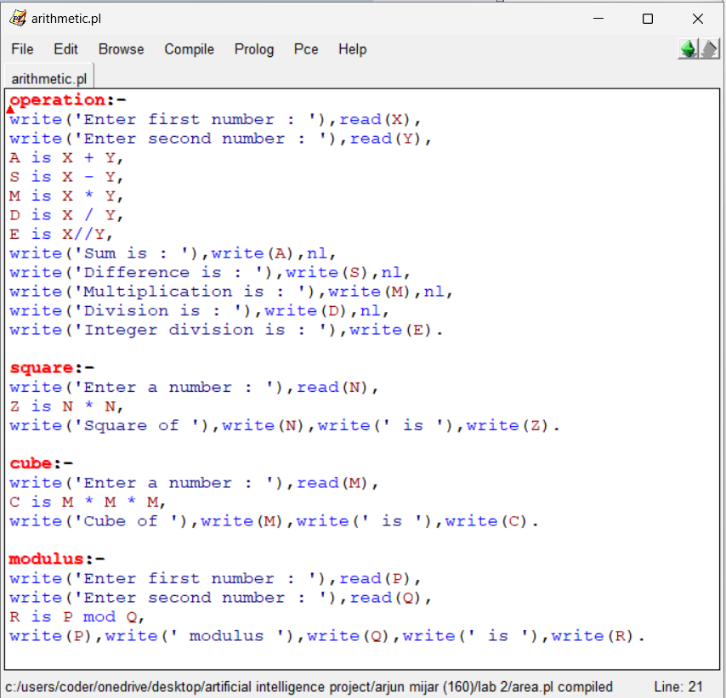

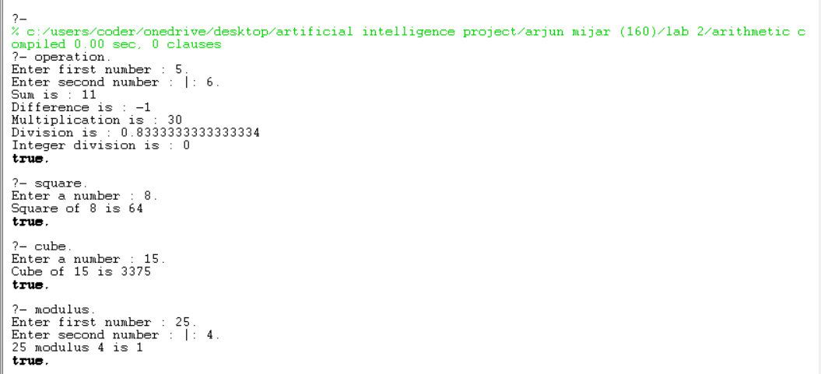

3a. Write a program to find factorial.

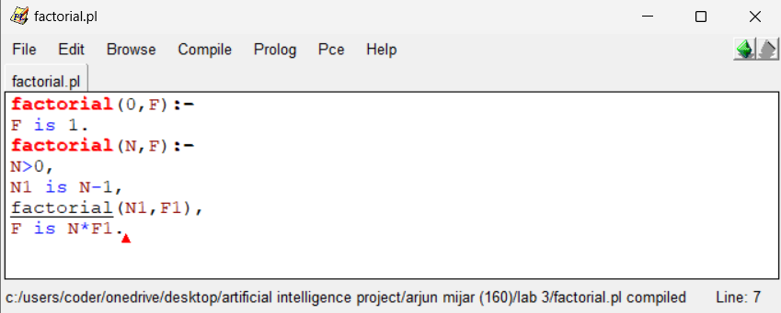

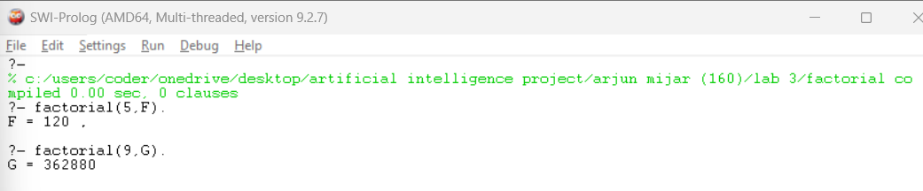

3b. Write a program to find fibonacci.

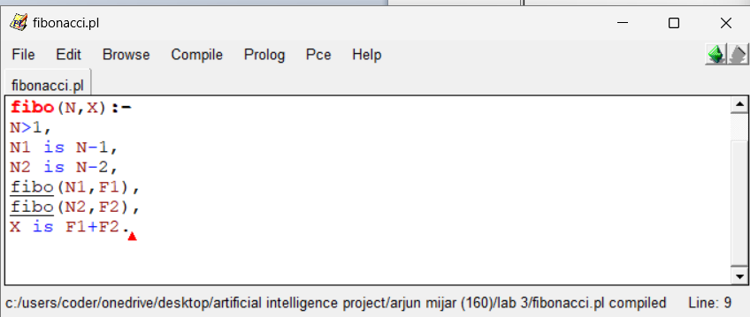

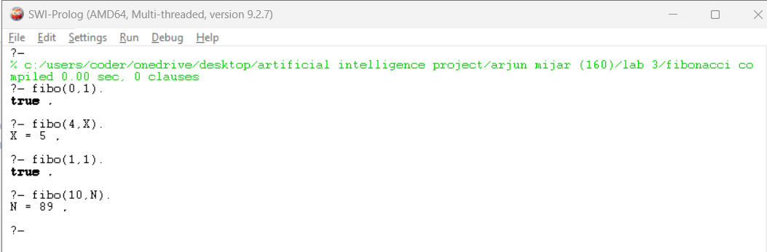

4a. Write a program to find the GCD and LCM of a given number.

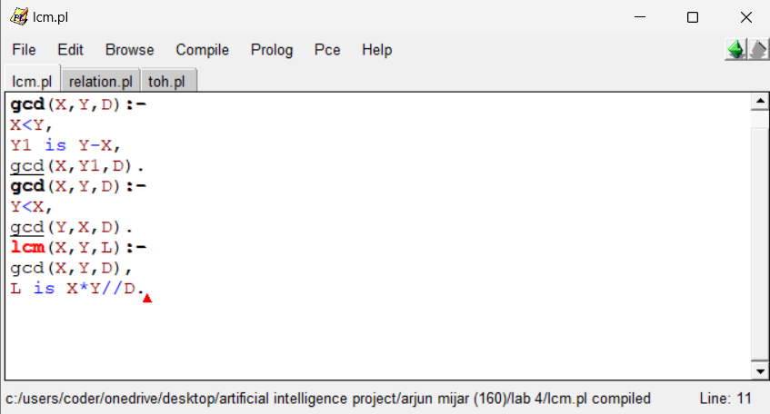

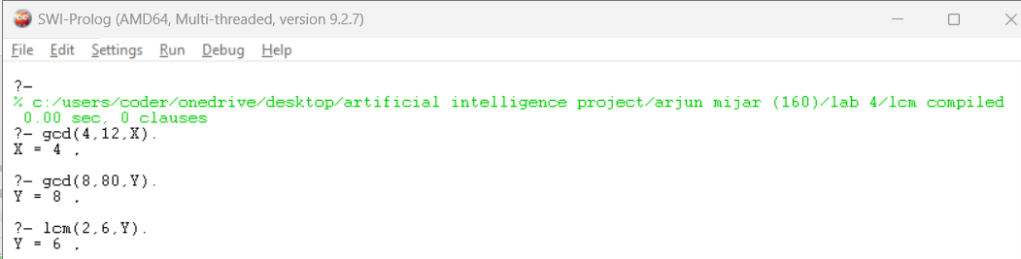

4b. Write a program to find the relation.

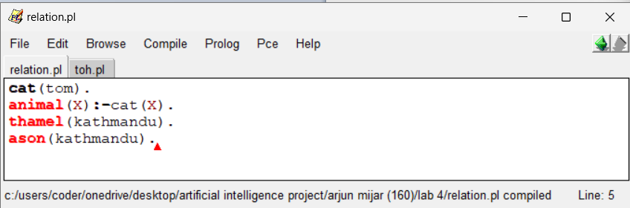

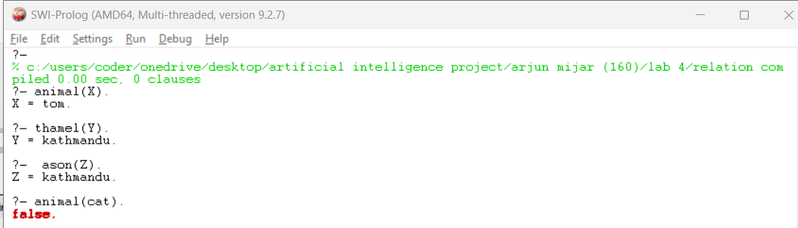

4c. Write a program to find the solution to a tower of Hanoi problem.

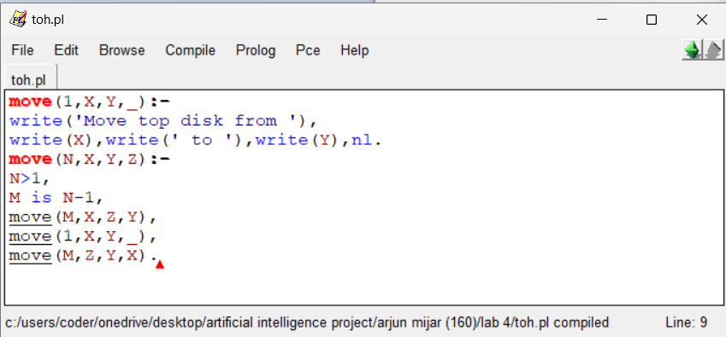

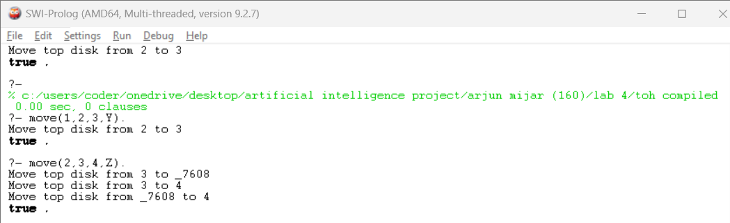

5. Write a program to find an area of a triangle.

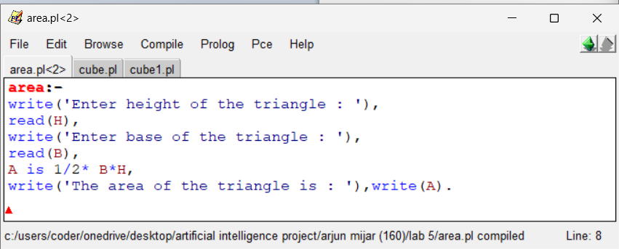

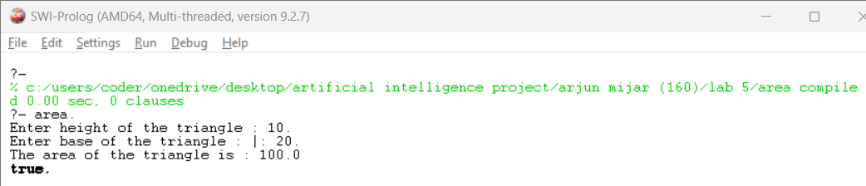

5b. Write a program to find the cube of a given number.

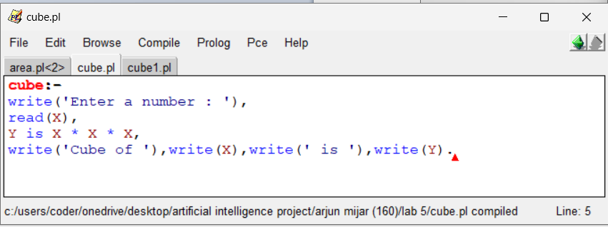

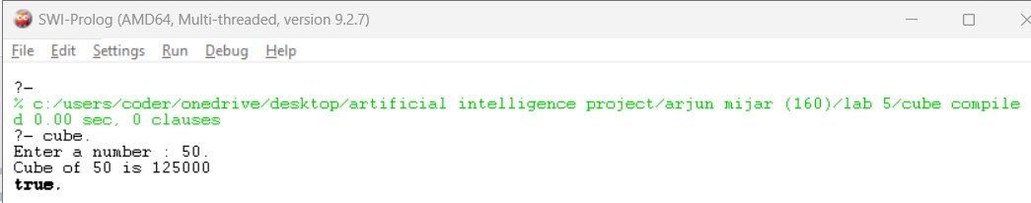

5c. Write a program to find the cube.

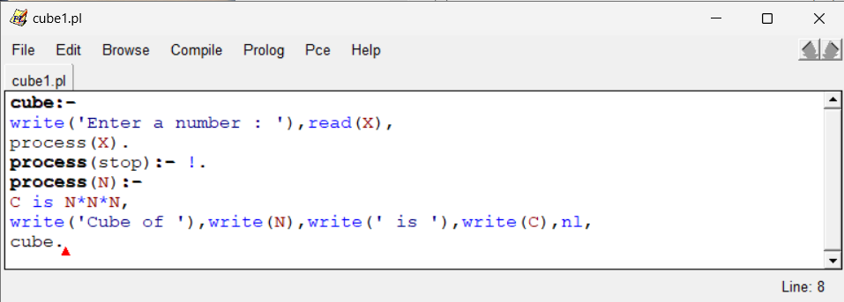

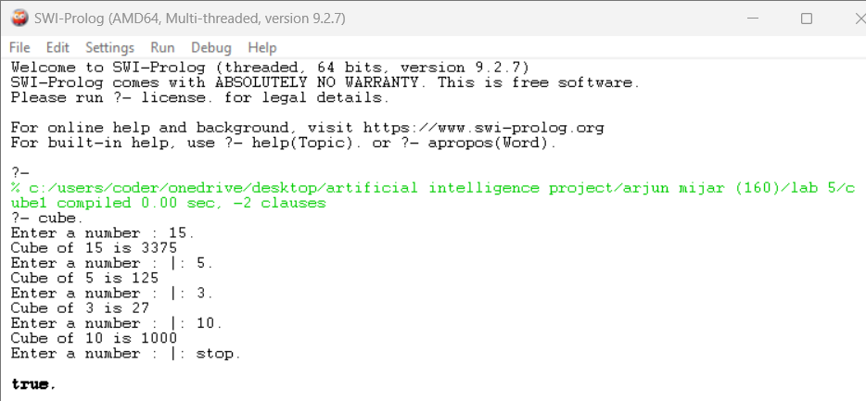

6a. Write a program to concatenation.

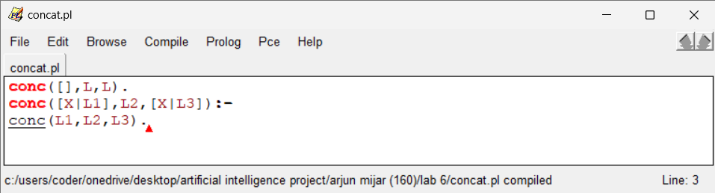

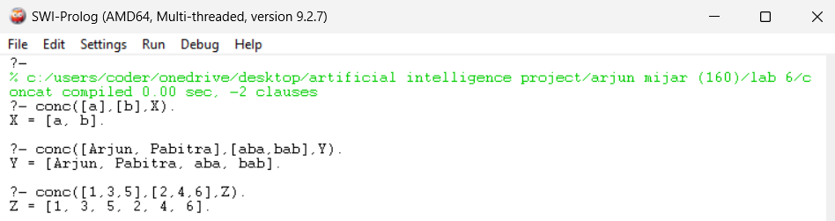

6.b Write a program to delete.

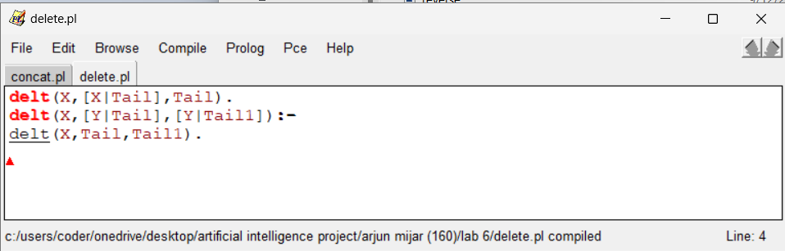

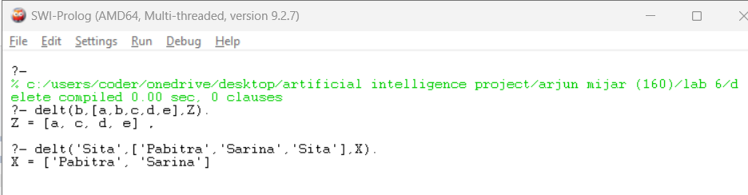

6c. Write a program to count the length of list.

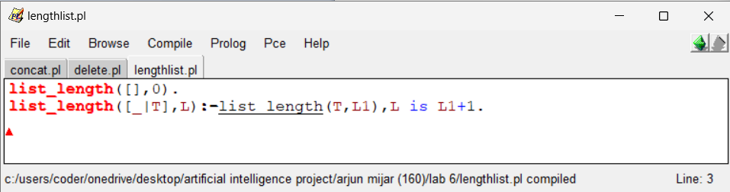

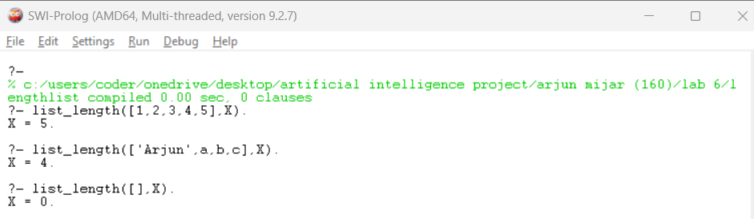

6c. Write a program to check whether the given member is list or not.

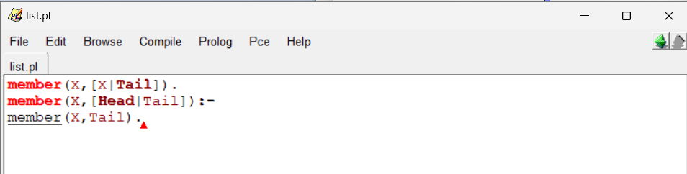

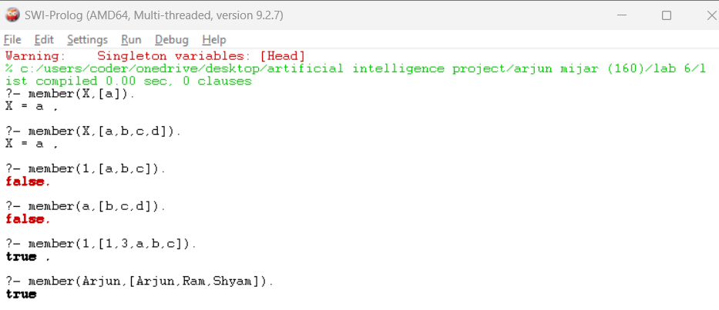

6d. Write a program to reverse a list.

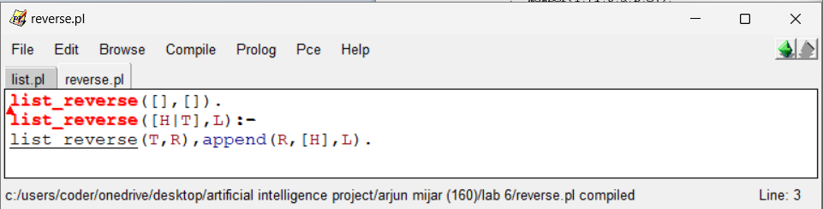

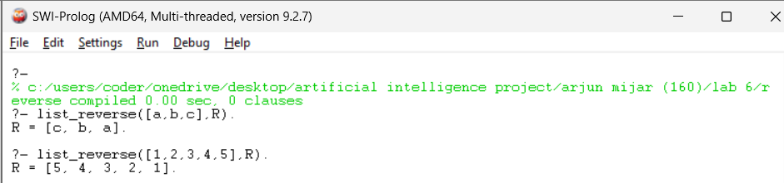

7a. Write a program to find the greatest number among given number.

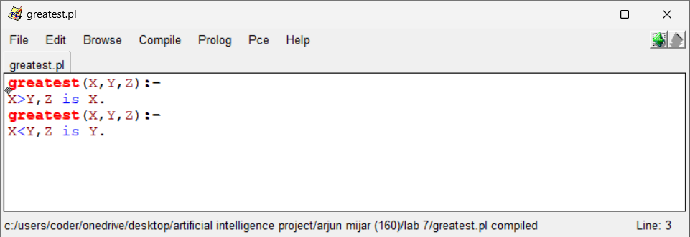

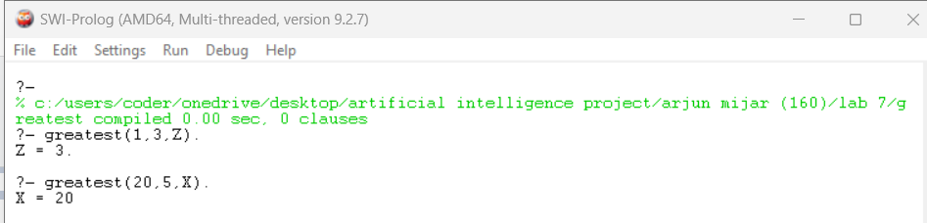

7b. Write a program to check the palindrome.

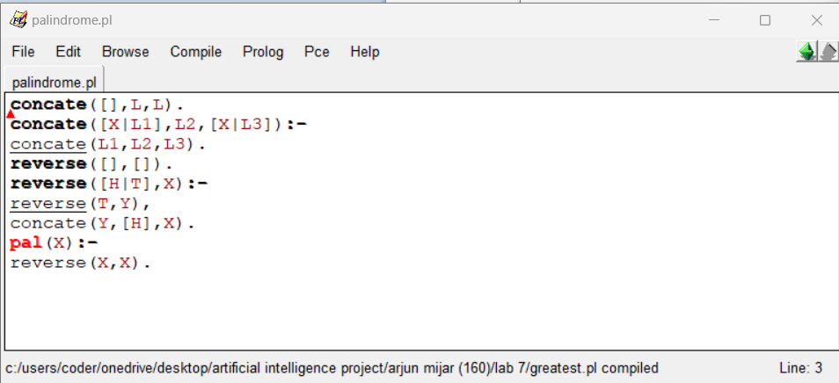

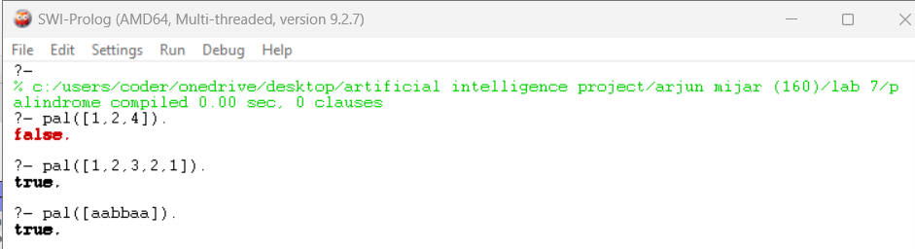

7c. Write a program to find the permutation.

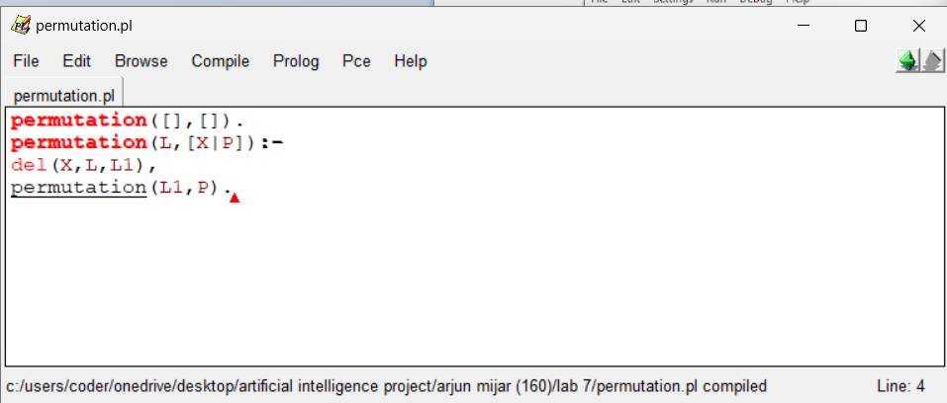

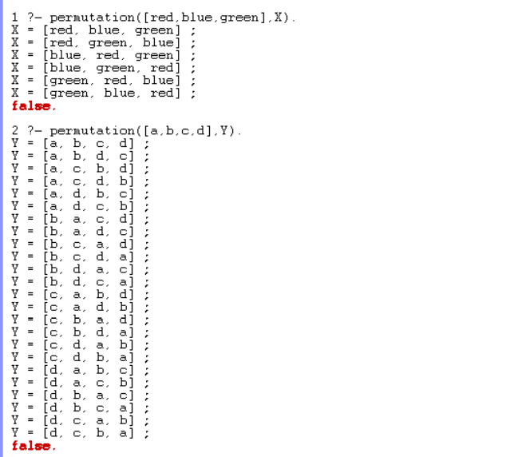

8a. Write a program to find the average of a given number.

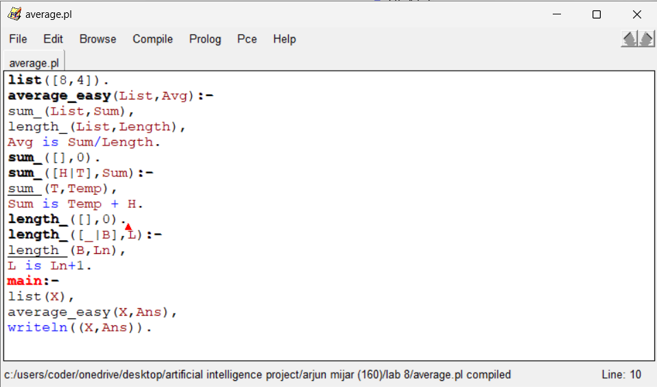

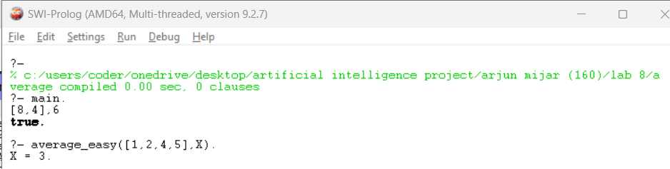

8b. Write a program to find the factor of given number.

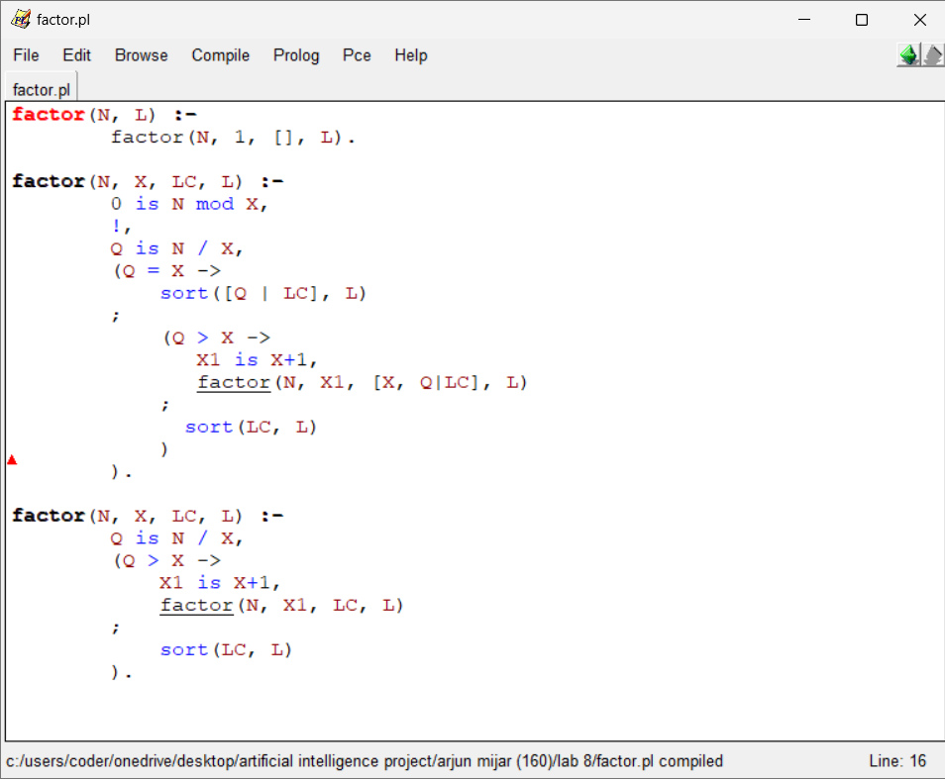

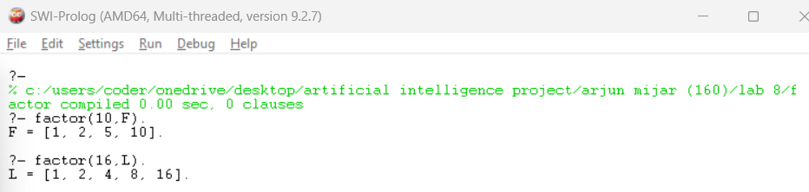

9a. Write a program to find the relation. (Who is mortal ?)

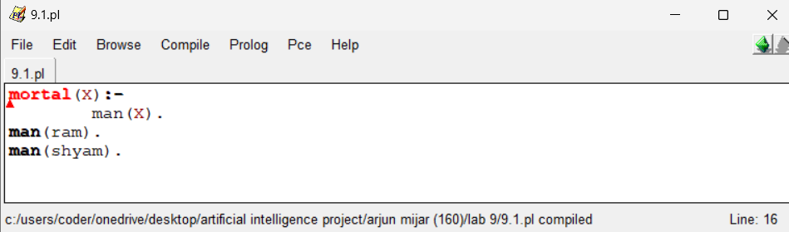

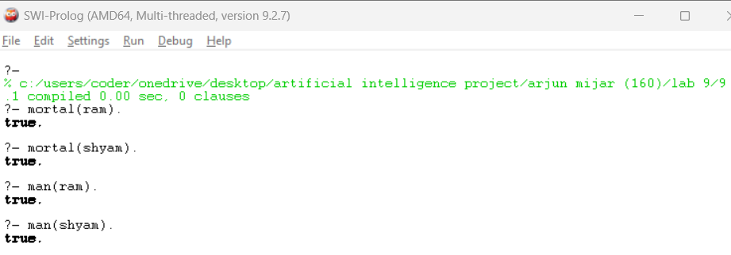

9b. Write a program to find the relation. (Which locations are in Asia ?)

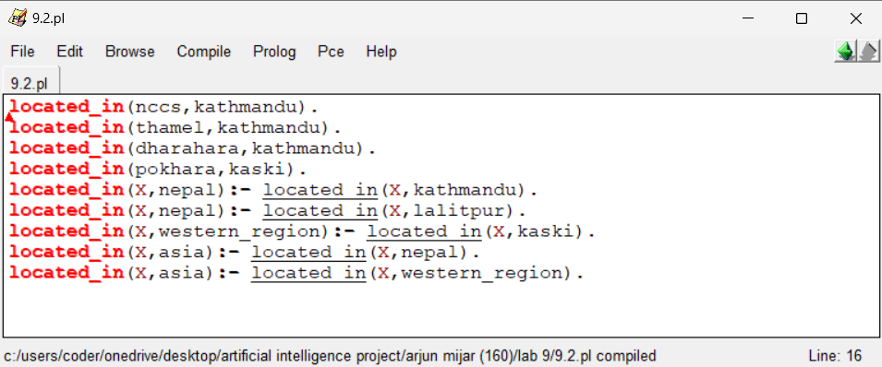

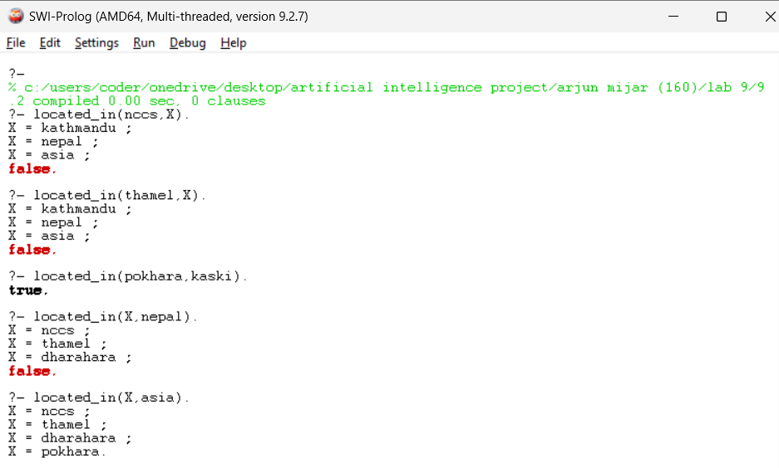

10a. Write a program to find the maximum number of given number.

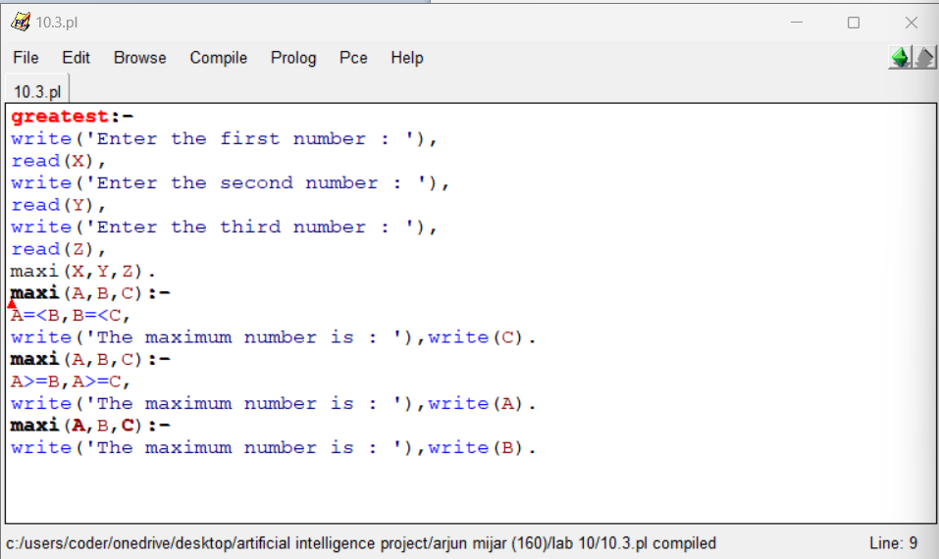

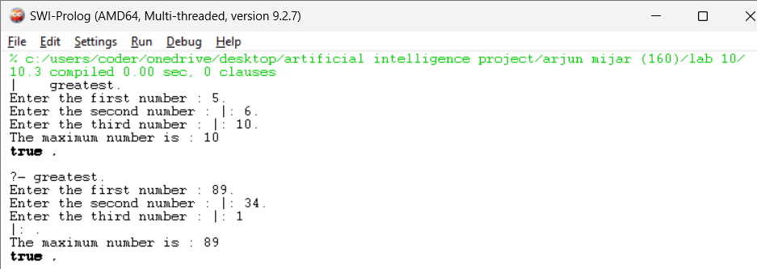

10b. Write a program to find the greatest number among given number.

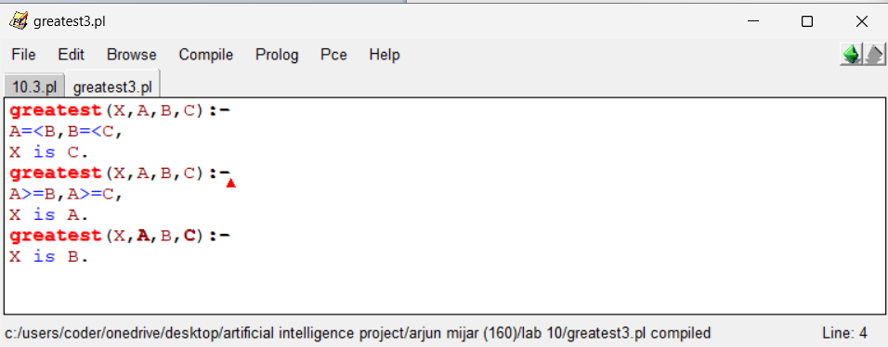

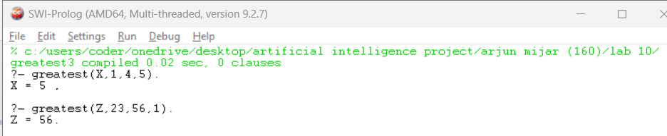

11a. What are the values of S, M, E, N, D, O, R, and Y that satisfy the equation SEND + MORE = MONEY?

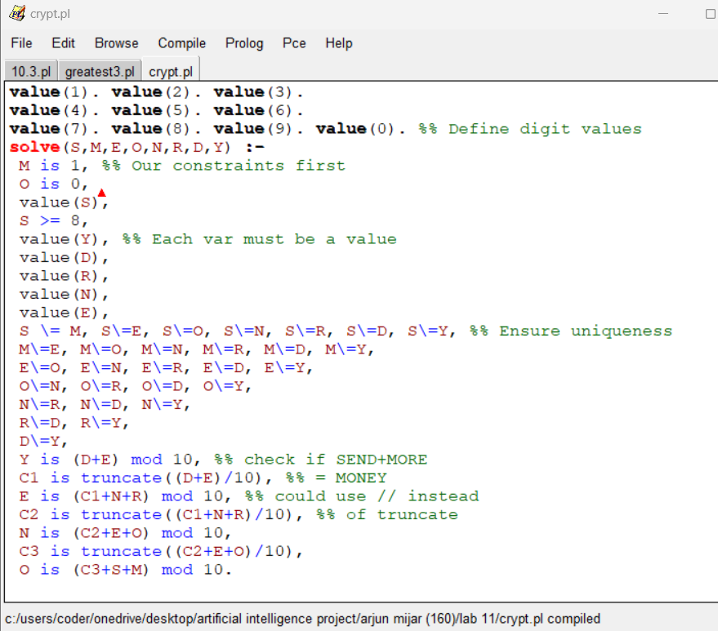

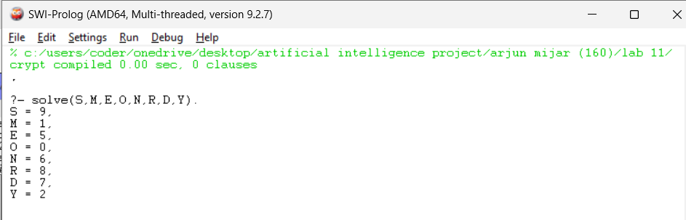

11b. Write a program to print a square of stars with a side length X.

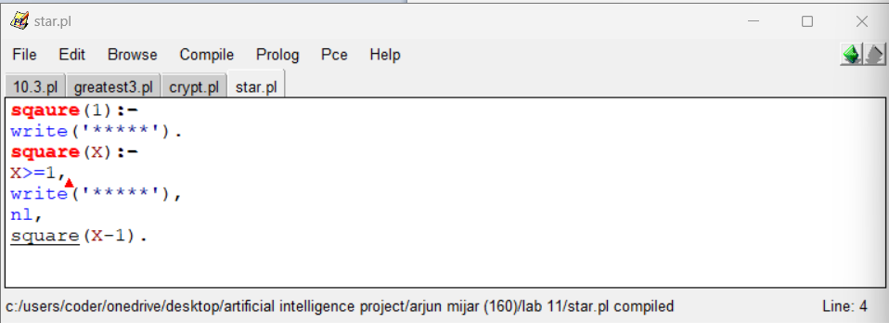

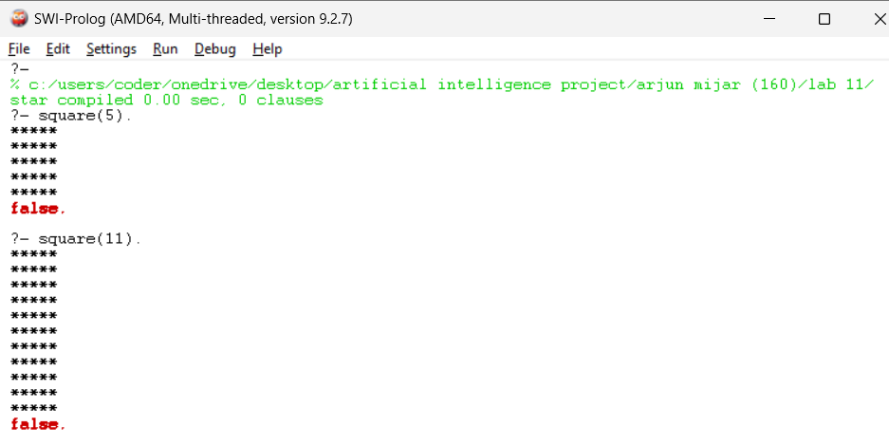

12a. Write a program to find the path from the start node to the goal node using breadth-first search.

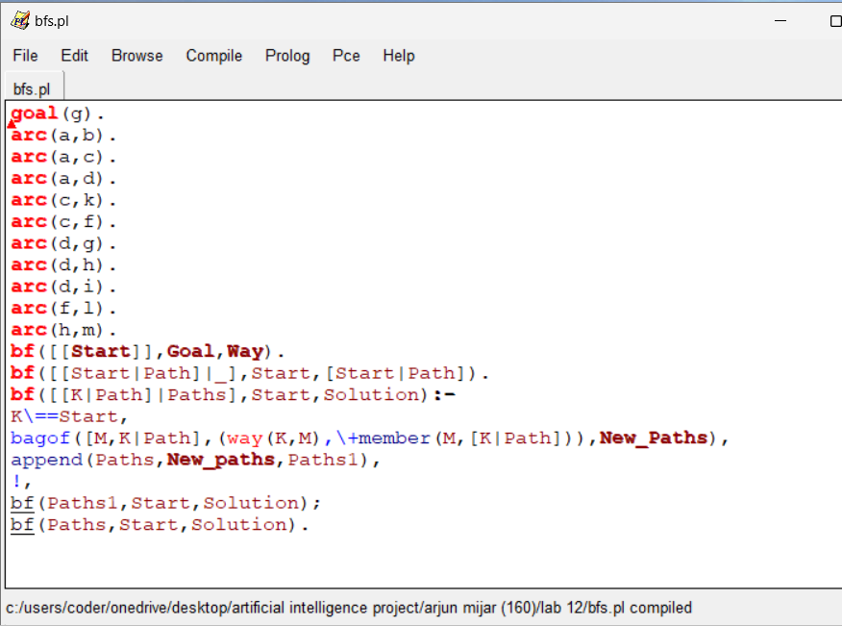

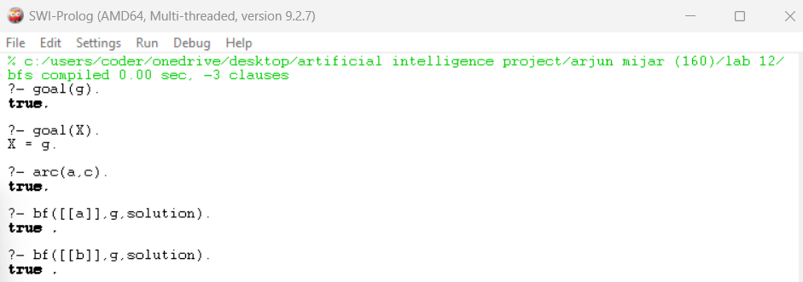

12b. Write a program to find the path from the start node to the goal node using depth-first search.

